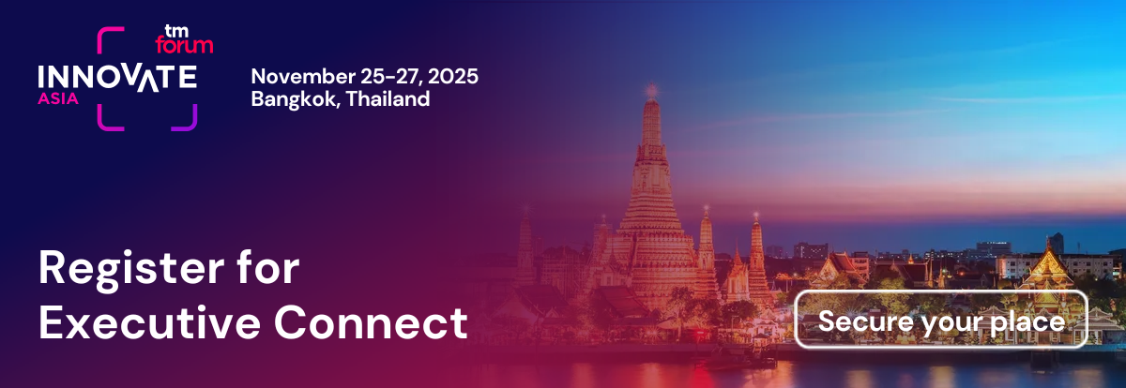
Dear [Your manager’s name],
I am writing to request approval to attend the TM Forum’s Innovate Asia event in Bangkok, Thailand, from 25-27 November 2025.
Innovate Asia is where AI-enabled autonomous innovation comes to life. I’ll see live demos, hear from experts, and discover how ideas are becoming reality.
With Asia leading the way in end-to-end autonomous operations, I’ll explore high-value use cases already in production and learn how AI-enabled telcos are accelerating growth.
The good news is that I can attend with a complimentary all-access pass if I take part in Executive Connect during the event.
Executive Connect is a meeting program where TM Forum connects selected service providers with leading solution providers via one-to-one meetings. I will be able to learn about new technologies, which could be of great interest to us.
Why Innovate Asia:
TM Forum has three Mission pathways that I believe will greatly contribute to our understanding of the industry:
- Composable IT and Ecosystems: Enabling agility by creating modular, interoperable systems and fostering ecosystem partnerships.
- Autonomous Networks: Driving efficiency through automation and self-managing networks.
- Data and AI Innovation: Accelerating innovation by harnessing data and artificial intelligence for smarter operations and new services.
These Missions are directly relevant to our current priorities and future ambitions. I want to deepen my understanding of how leading companies are approaching these areas, and Innovate Asia is the only place where the latest strategies, frameworks, and real-world case studies are shared and discussed in depth by those at the forefront of the industry.
The best place to learn from peers
Innovate Asia brings together over 1,000 telecom professionals, including decision-makers from the world’s top operators, technology suppliers, and digital innovators. The event is designed for open knowledge exchange through presentations, workshops, and informal networking. It is renowned for its collaborative atmosphere, where peers openly share both their successes and lessons learned.
By attending, I will:
- Gain firsthand insight into how other organizations are tackling the same transformation challenges we face.
- Participate in discussions and workshops focused on TM Forum’s three missions, learning directly from those implementing best practices.
- Build relationships with peers and experts, creating an ongoing network for support and collaboration.
Bringing value back to our team
After the event, I will share key takeaways, new contacts, and actionable ideas with our team-helping us accelerate our own initiatives in line with industry best practices.
Thank you for considering my request. Attending Innovate Asia will not only help me grow professionally but will also position our team to lead in the areas that matter most to the future of telecom.
Best regards,
[Your Name]

